Connectivity of On-Premises Data Center to AWS Cloud
On premises Servers in Mumbai placed 1 as Firewall which act as a Customer Gateway and other DomainController which server will help to make AD :
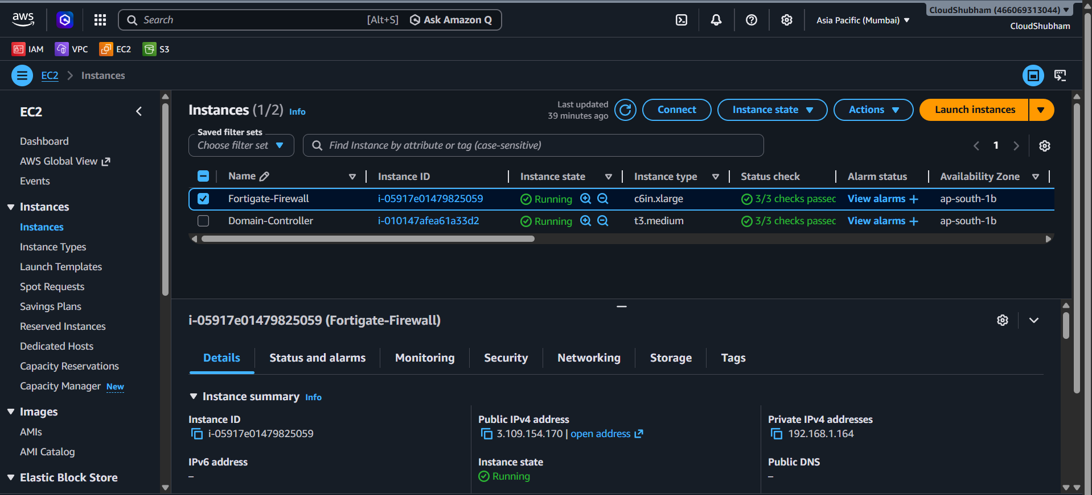
There is 1 VPC which is Cutom VPC with CIDR range 192.168.1.0/24 :
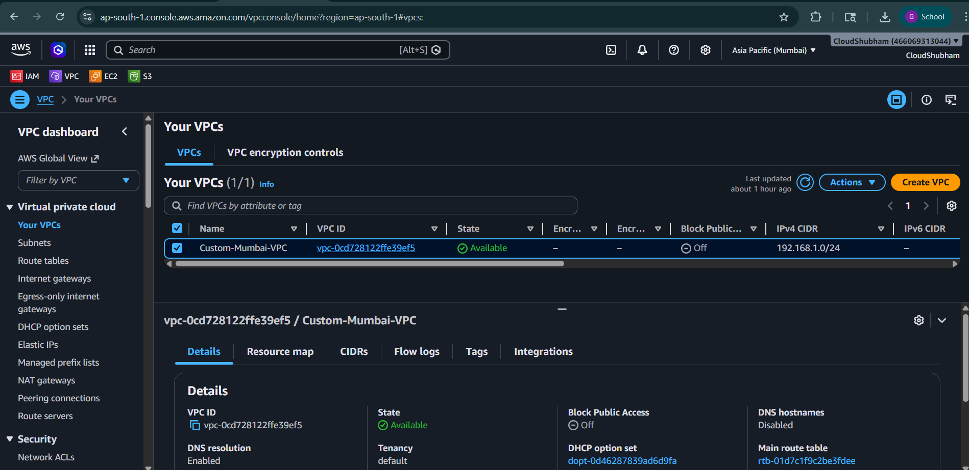

There is 2 Custom Subnets :
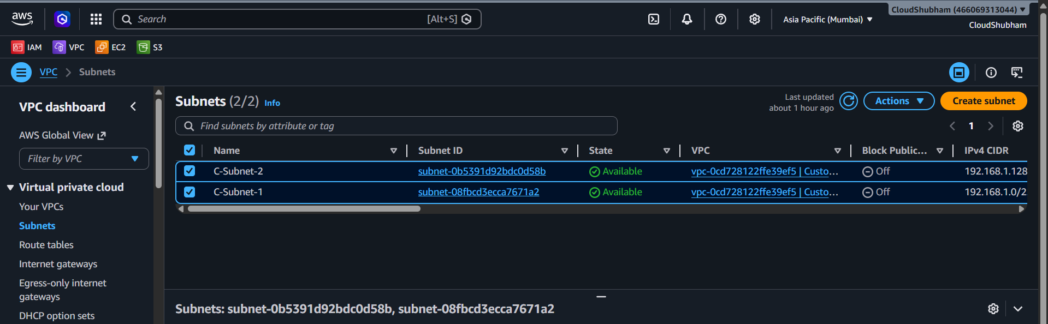
To name the Network interfaces card of both firewall and DomainController ( Domain controleer will communicate with firewall if ENI will STOP the change Source/Destination )
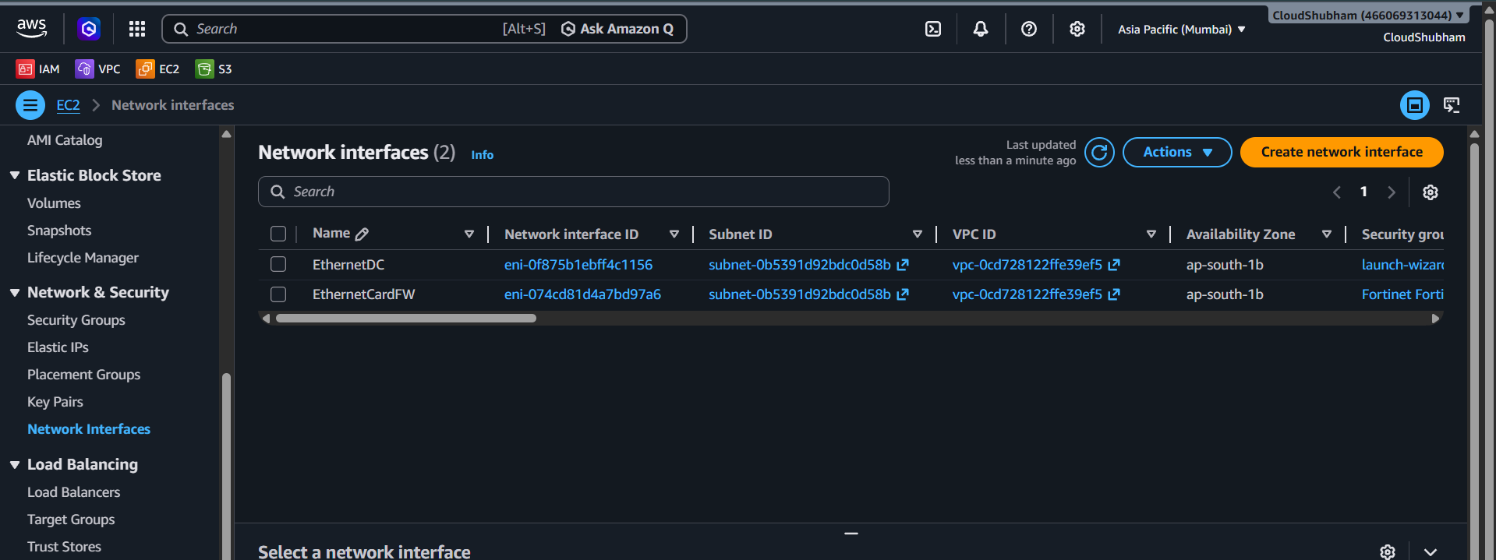
There is 1 Route table with local, ENI of Firewall and Internet gateway :
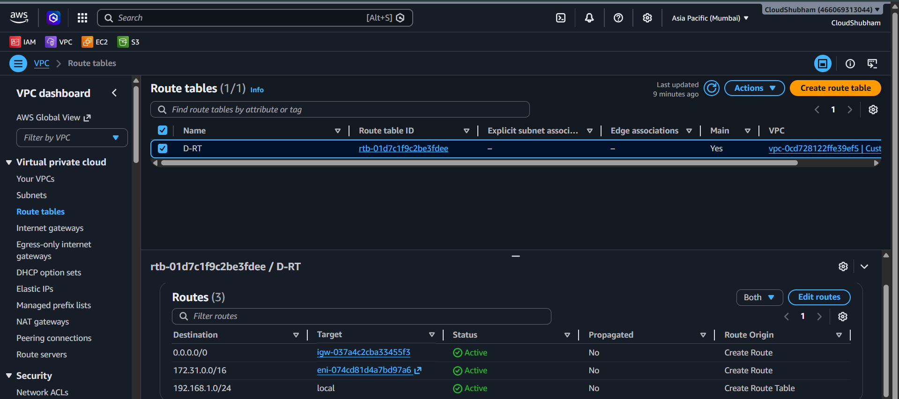

Cloud : There is one Server running on cloud which will sync work from Mumbai On-premises Data center
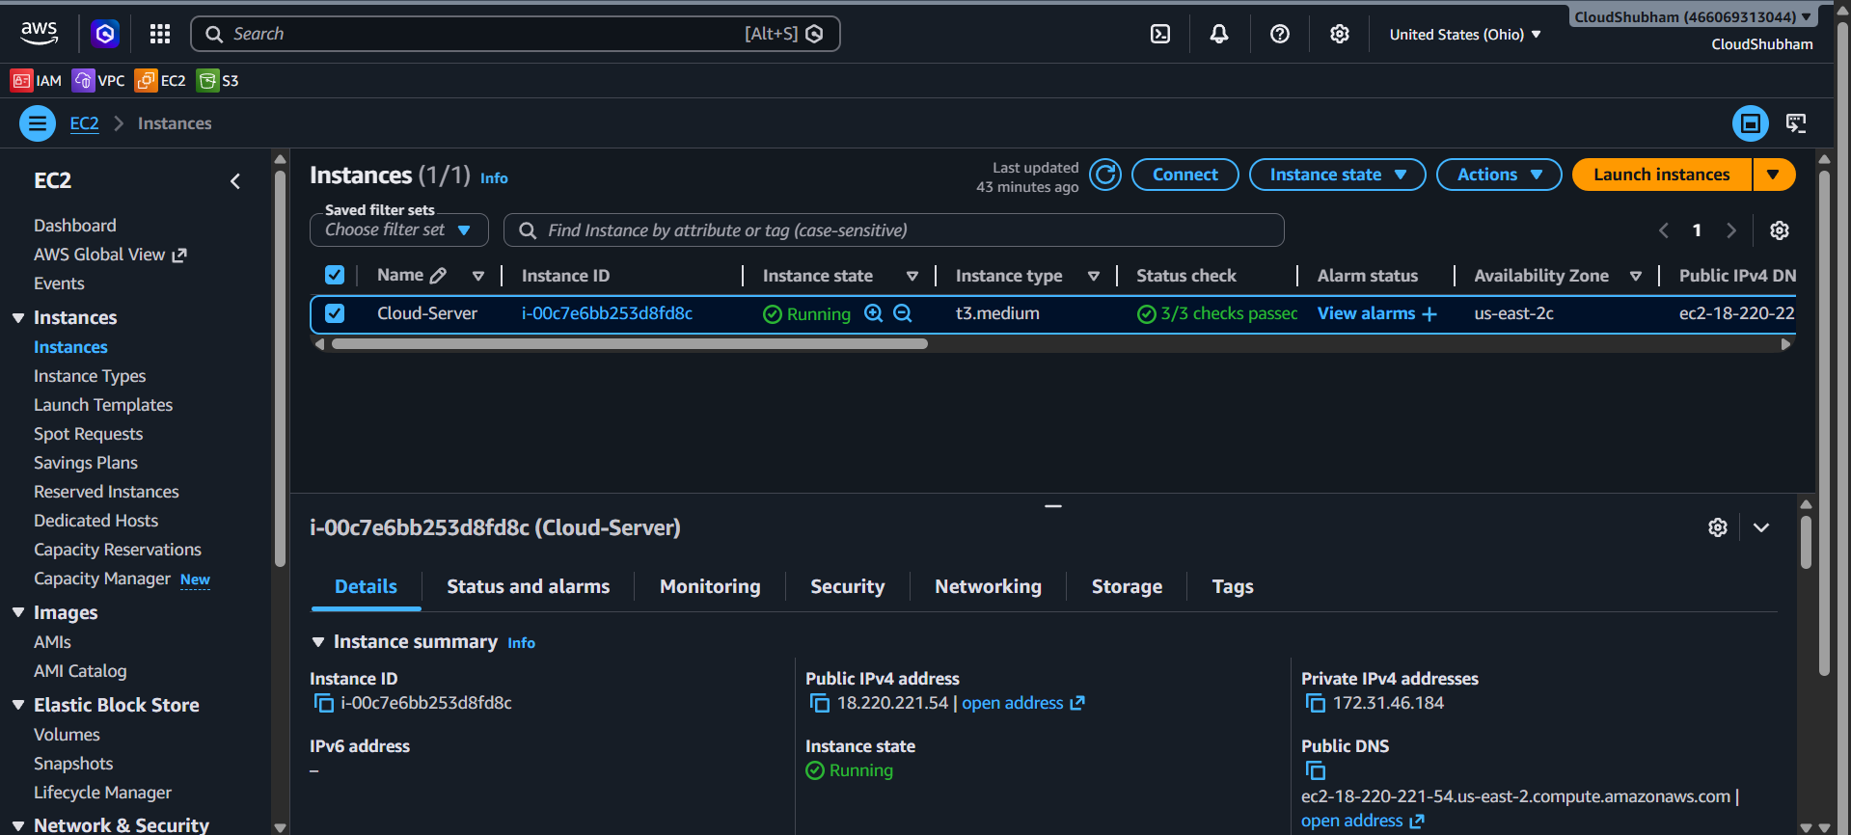
There is one default VPC in Cloud Ohio region :
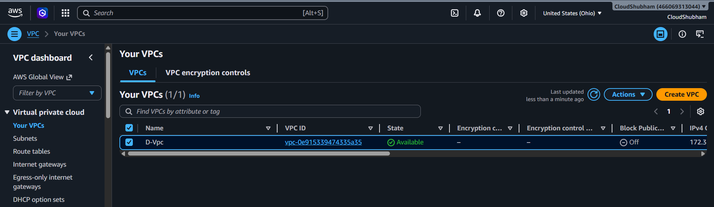
There are various public subnets :
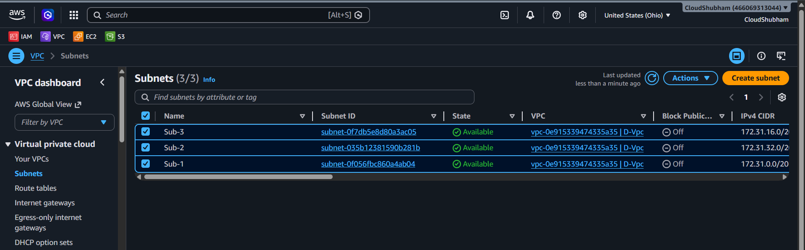

There is Route table which do help in communication with local, VGW and internet gataeway :
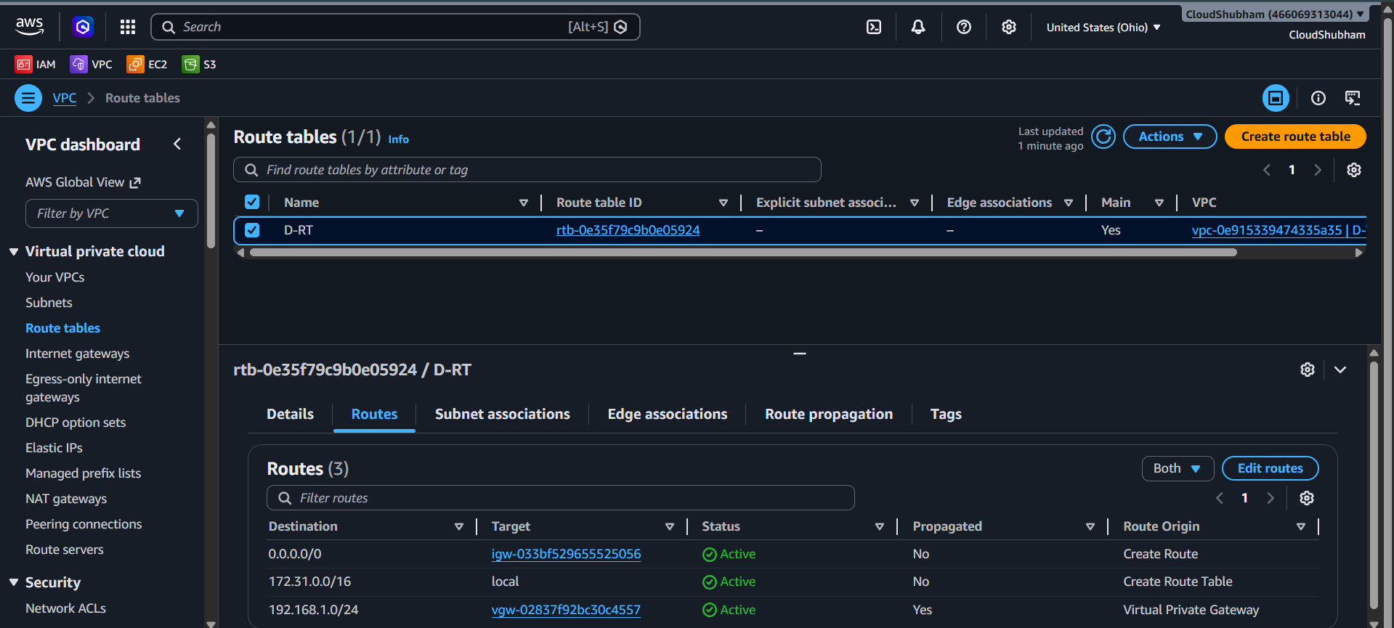
Making a Customer Gateway which is a Fortinet Fortigate firewall located on On-premises side :
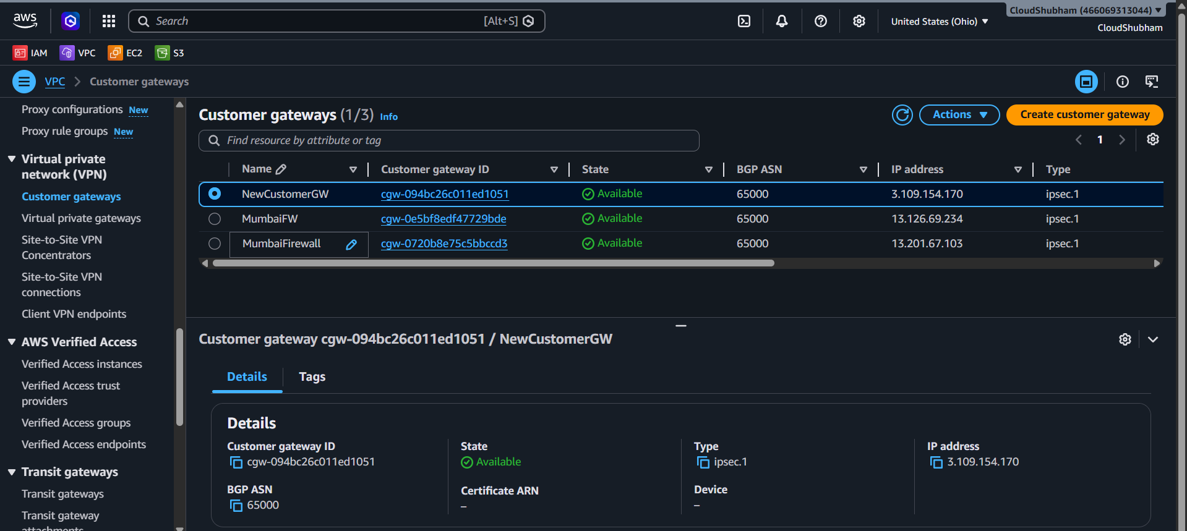
Creating a VPG and attaching Customer gateway at Cloud side for a communication from this gateway to customer gateway :
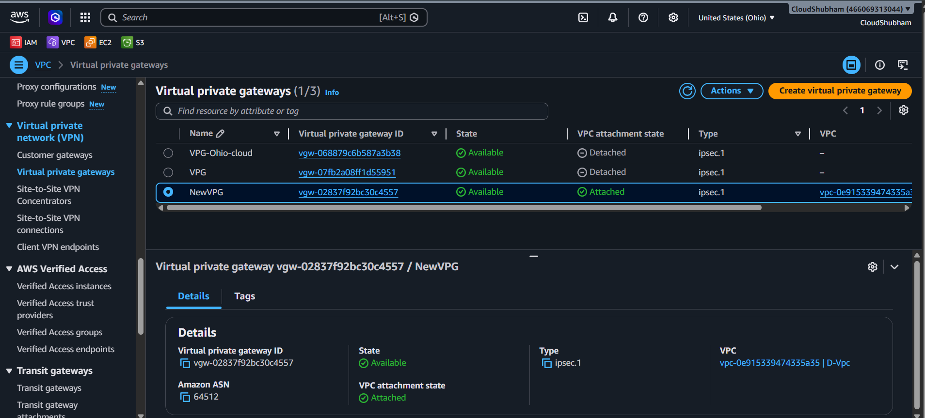
Having a VPN connection in between On-premises and Cloud this VPn will setup between Customer gateway and VPG ( And here the status of 2 Tunnels which are in 2 differnet AZs are also in UP status and active )
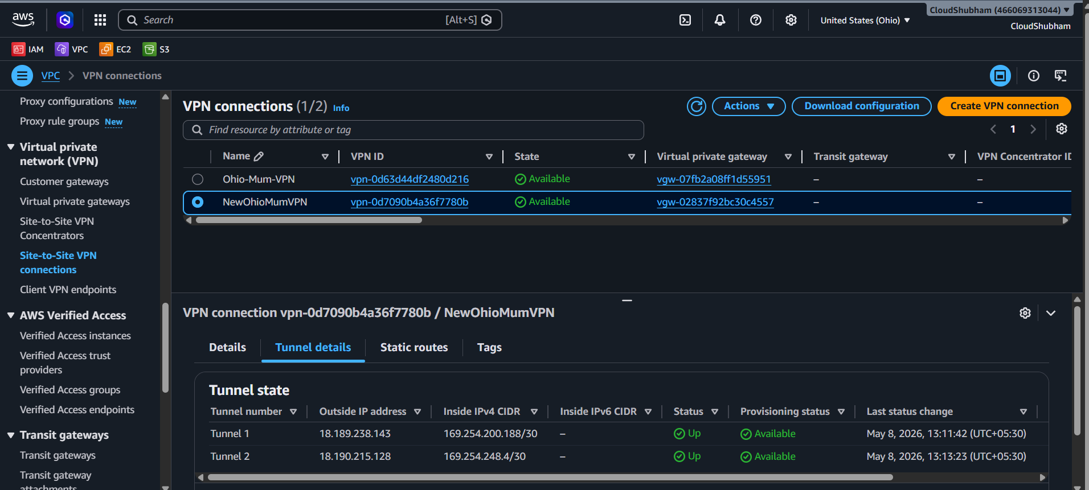
At Fortinet FortiGate firewall side the tunnels are UP as we configured on Fortigate Console for both of this 2 tunnel Scripts were run :
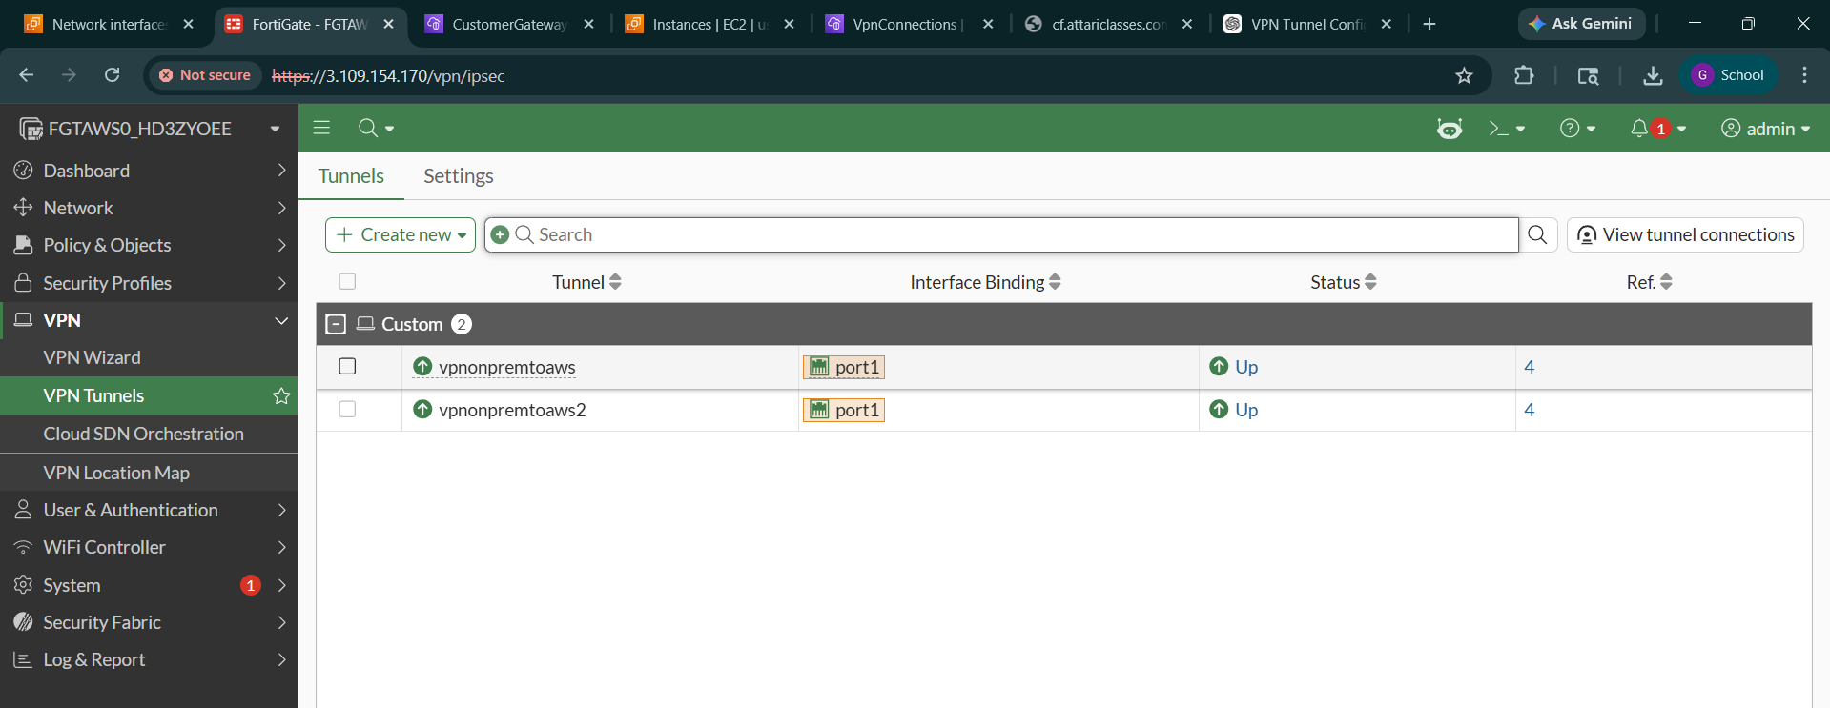

At last to check whether the Ohio region is sending Ping request to Mumbai region which is considered as On-premises Private IP Pinging is done :
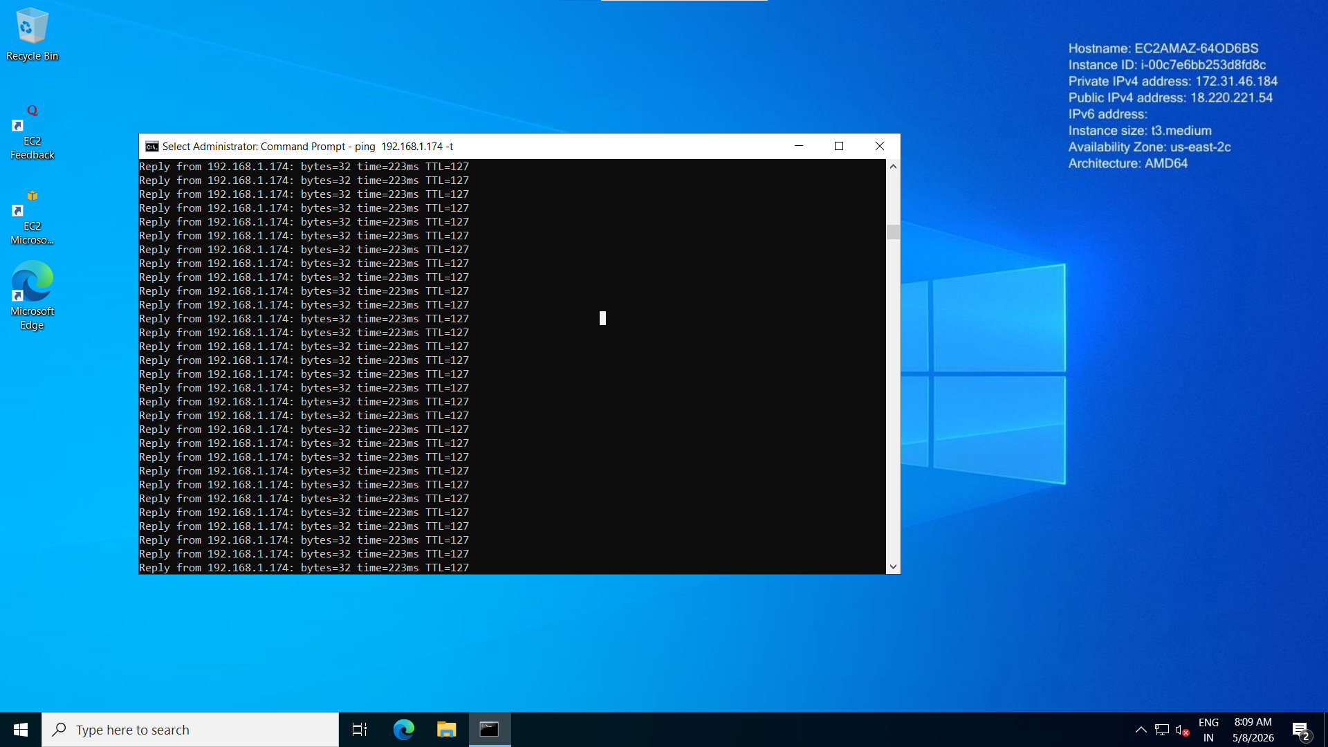
At Mumbai region side pinging is done to check connectivity with Ohio region for smooth connectivity :
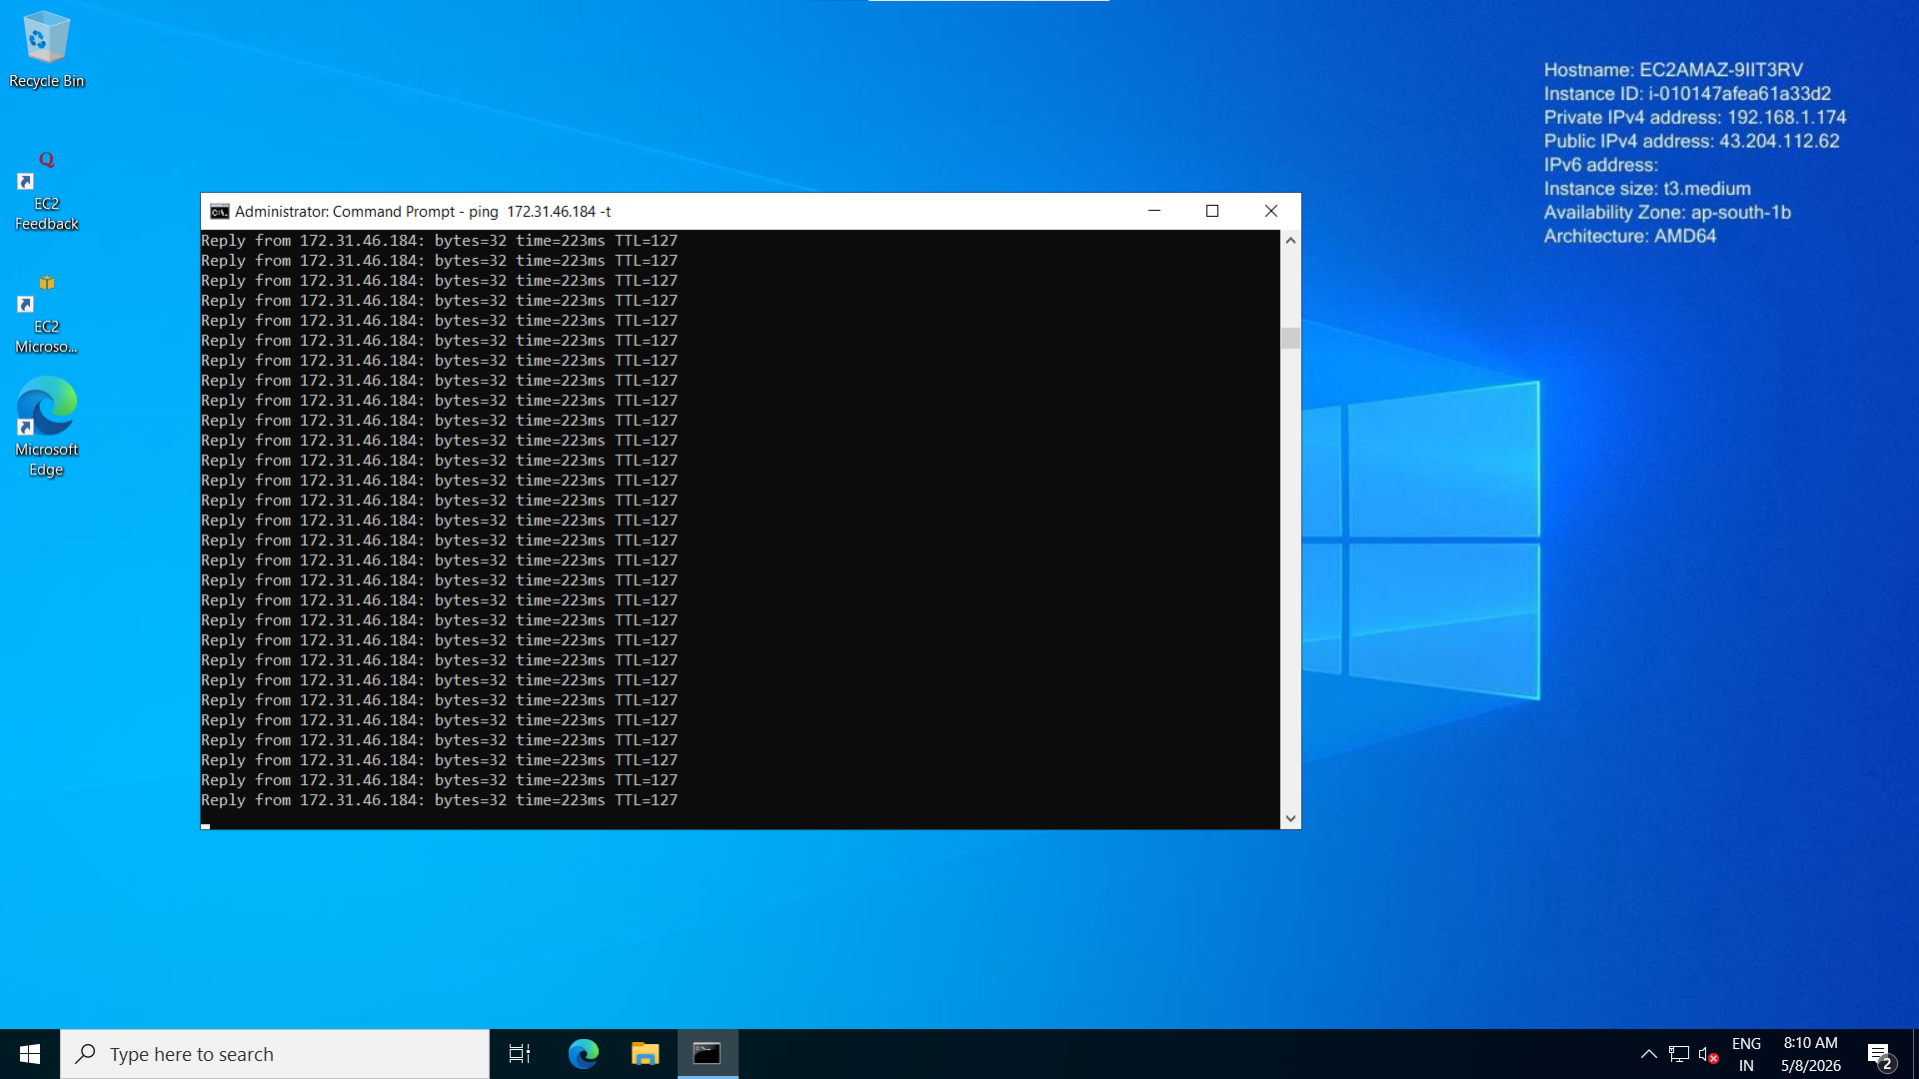

Now, working on adding Users which was created in Mumbai region as admin1 and admin2 and syncing that users in AWS Directory service and attaching that users to roles creted via IAM role:
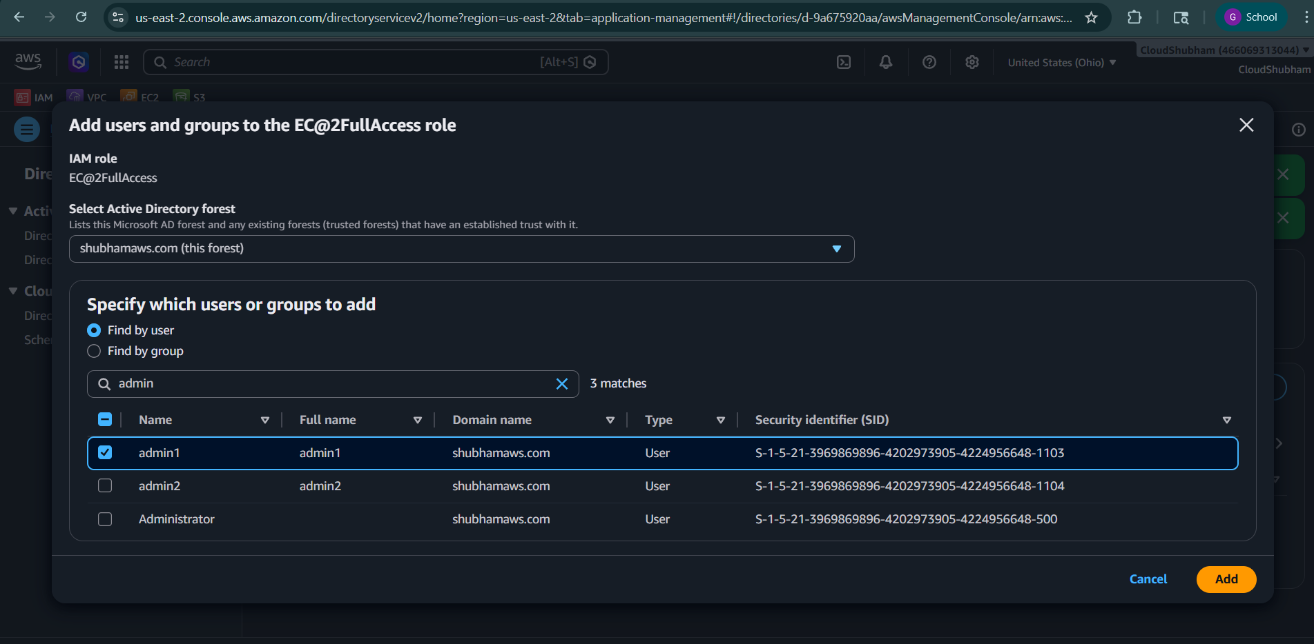
Admin2 user get access of S3 Full access :
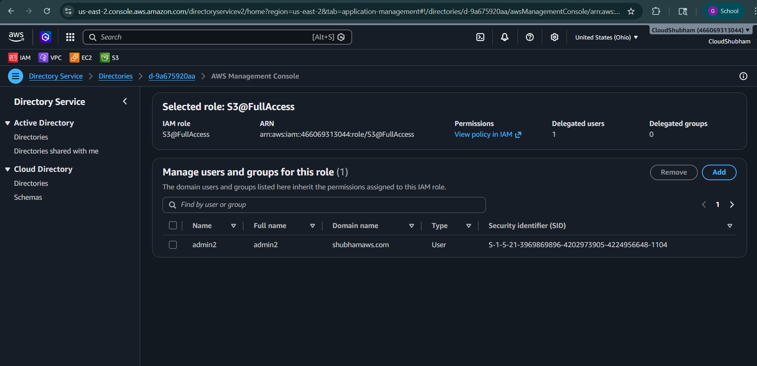

Trying to connect to aws console for both of the users using URL provided by Directory service which is customized :
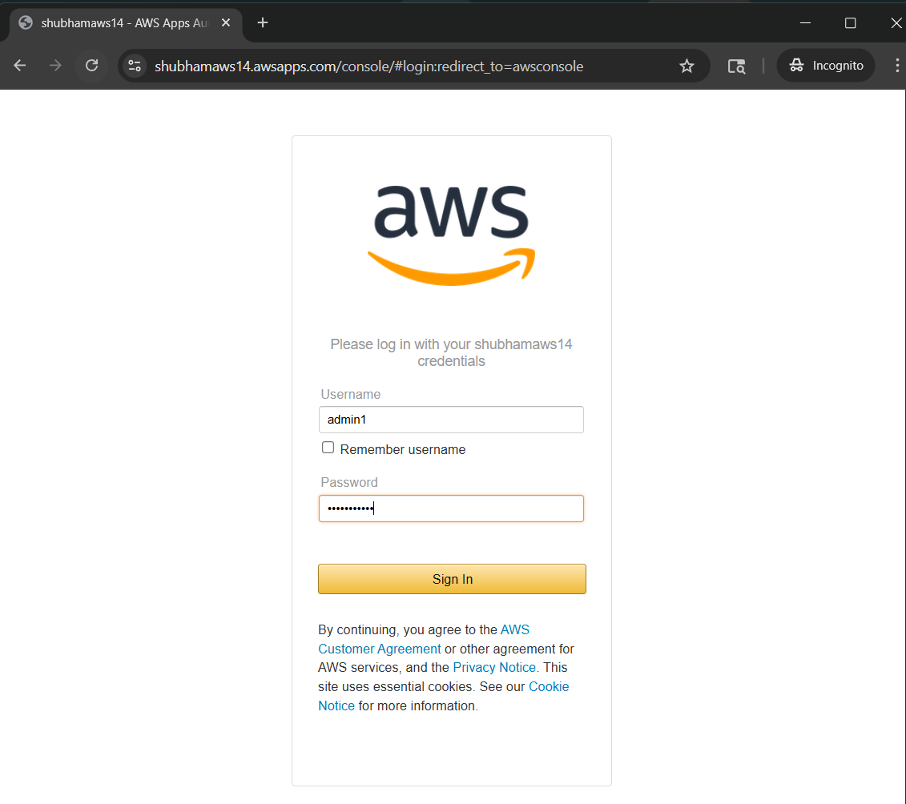

As we can see admin1 user successfully got loginned :

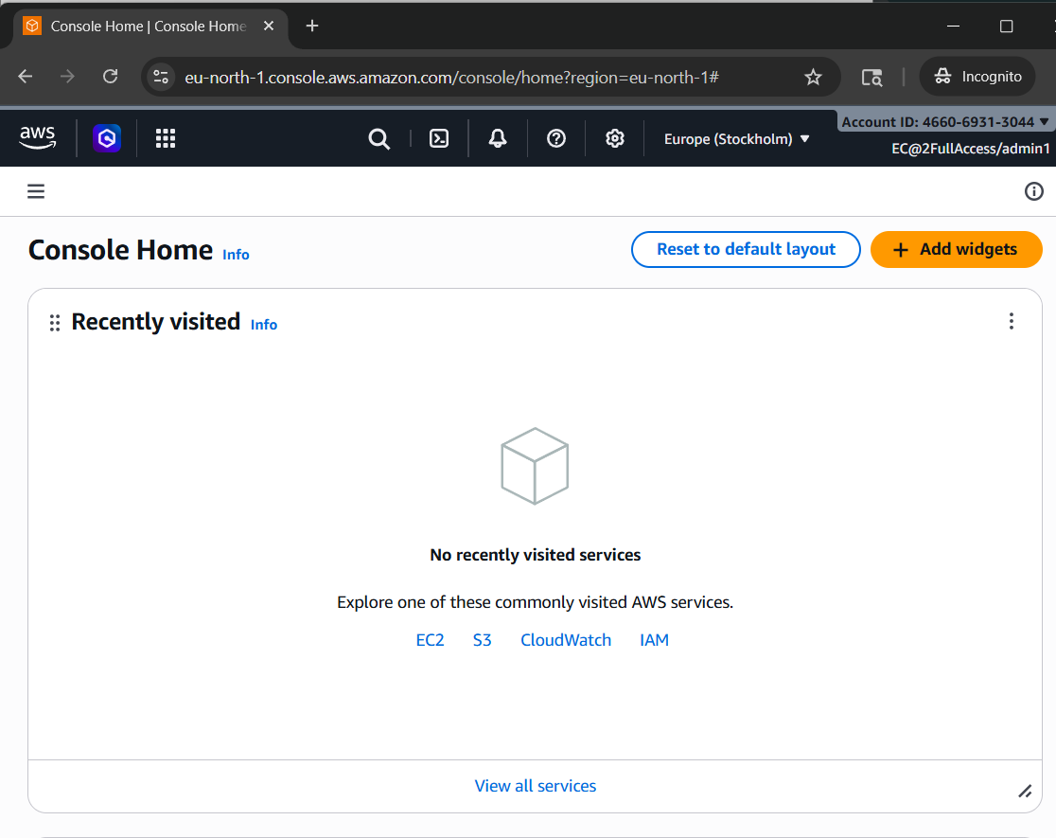

Admin1 user can see Ec2 instances :

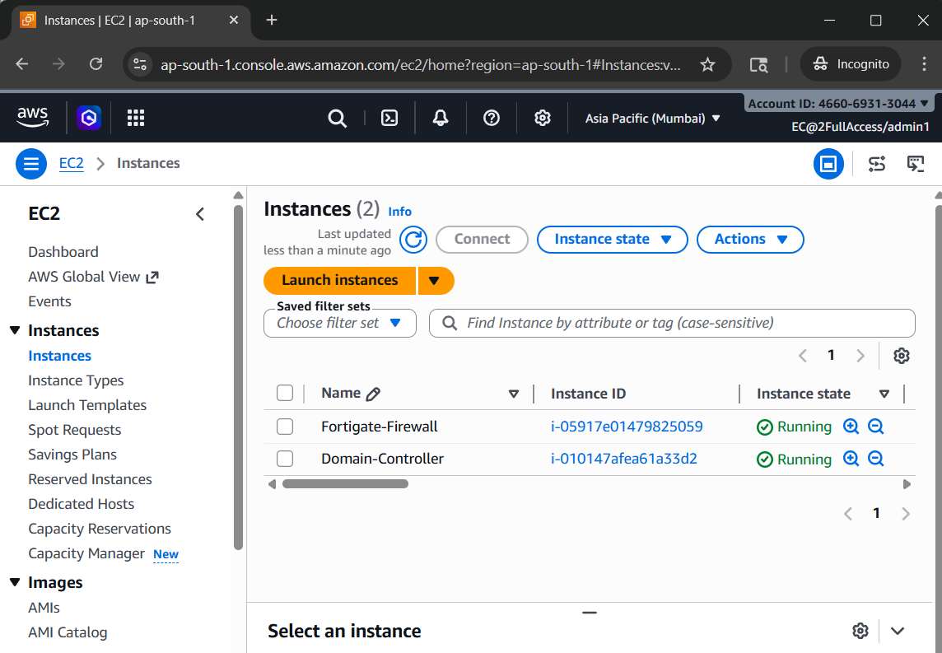
Admin1 is given as EC2 full access as a role :

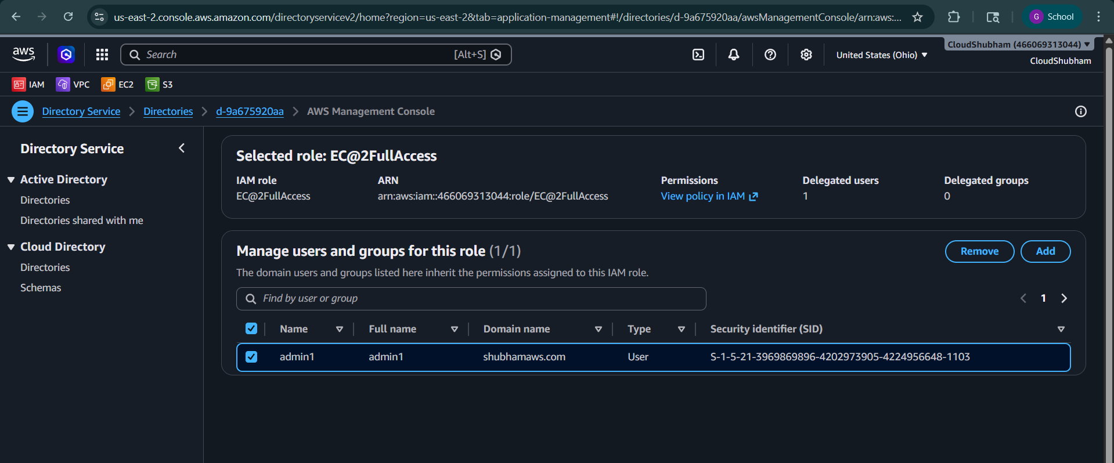

We can see all the roles created by IAM roles specifically to Directory Service can be seen and we can add users here also :
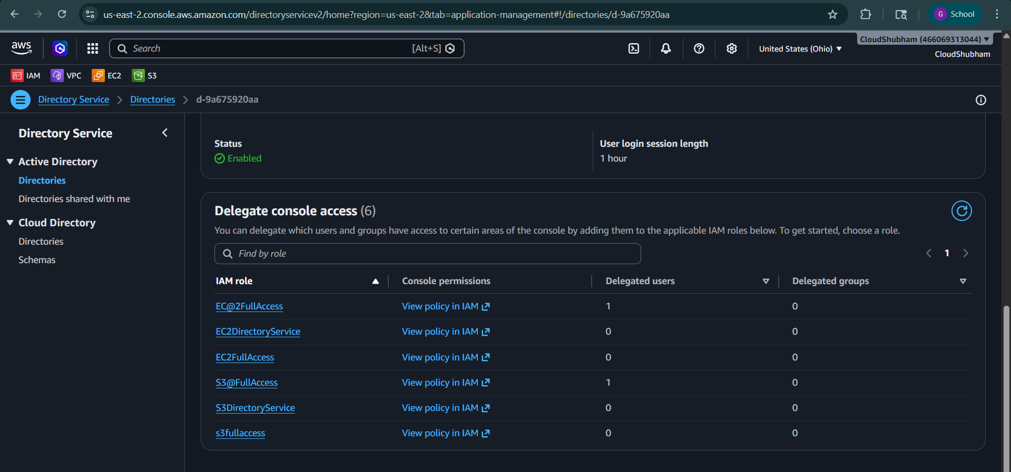
As admin2 is not able to access EC2 because it gave S3 full access :
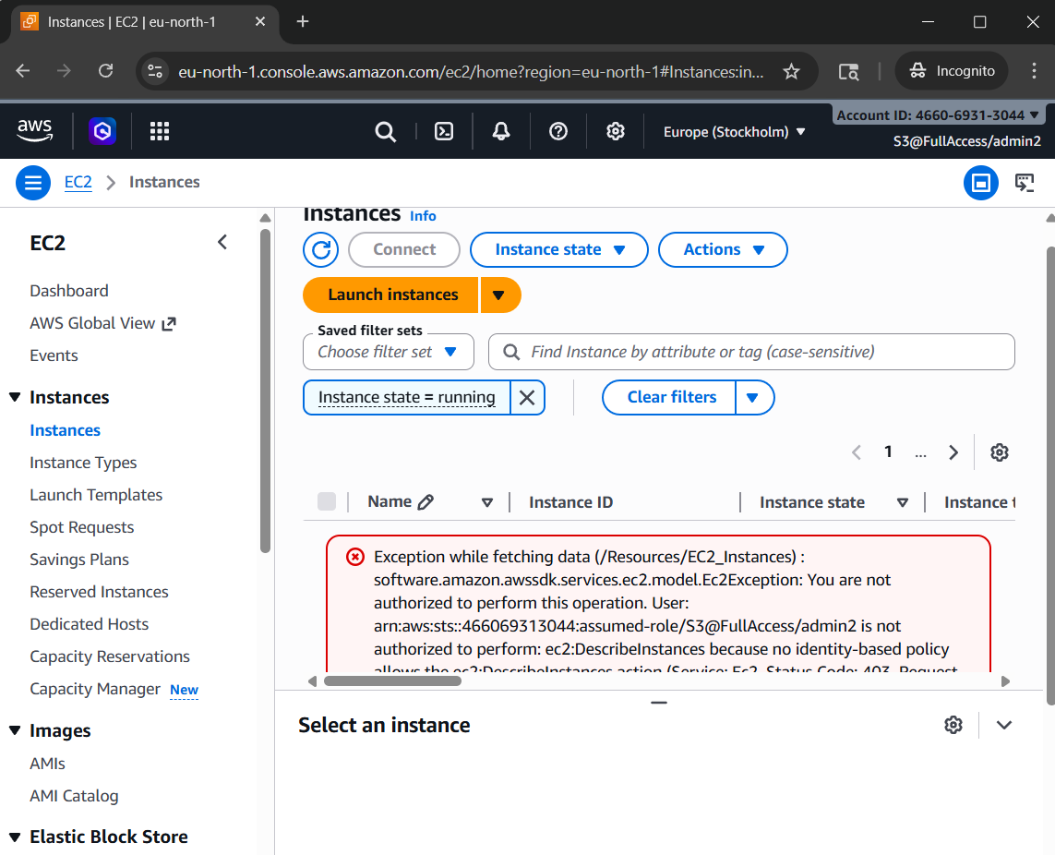

Create custom VPC in Mumbai and also custom subnets and route table with IGW

Launch EC2 with Fortinet fortigate firewall, in network remove all SG and only one SG edited as All Traffic and nor key pair select proceed without key pair.
ANd also name N/W interface as EthernetFW

Now new EC2 instance DomainController and edit windows as 2022 base with t3.medium and create new KP and also chose the only Neetwork or subnet in which FW is there

Launch EC2 as Cloud-Server in Ohio regions same as Domaoin controleler configuration

In Domain controller go to Server Manager and add roles and features as load complete. Select Active Directory Services, and then next install
Then caution button click and then promote to domain controller and then add new forest add your dns name and pass and next and install what ot give

shubhamaws.com

computer management by clicking on Satrt button as right click and then in users administatator change password

and next now take rdp of Ohio server and in Windows defender fW off the 2 firewalls

now connect to rdp for Domain controller and type customized password as there was no KP and in that turn off Firewalls which was 3
Active directory users and computers in DC
Create 2 users admin1 and 2 with pass as customize one by right clicking on the users side list

Now go on Ohio cloud and make Customer G/W with attaching Mumbai FIrewall public ip
VPG on Ohio side attach to ohio only default VPC
and Vpn connection select VPG and Customer G/W and select static ip of VPC of Mumbai

Tunnel

18.189.238.143 aumemp6ig_unV8_9ZfN.IUDF13ALLrK6
18.190.215.128 6.MuZuyiWptb15ZLuhAqo1T_FdkADu7u

Download config
Fortinet
5.0 gui

Fotigate open address and then copy paste the script and paste ip and secret key of tunnel and then run on Console of fortigate and also check for important part VPN tunnels should be minimum 1 should up Status

then edit Route propogation in route tables tab and enable VPG allow so automatic route is added for Mumbai

and add route in Mumbai region for ip range of Ohio vpc and then add ENI card of Firewall as entry

stop the change source destination check in networking in actions buttion of fW instance

And at last pinging is there between 2 servers

Nw going to AD service in AWS Directory service and enter DNS name and network cidr range of Mumbai region and wait for 5 to 10 minutes and also make 2 Roles for EC2 and S3 as fullaccess which works under ddirectoey service

at directory service enable Management console and have own url named and then try to login via that URL only

and at last delete all things like uswrs and diable console and delete directory service
terminate ec2 instances
delete VPN connection first then detach VPG and then delete then delete customer gateway

